Cone Zone Social Media Messages - Targeting General Public/All Drivers
Campaign focus: May 15 - August 31, 2023

Below is written content that can be used for your social media posts. If you are changing or adding to any of the messages here, please always include the hashtag #ConeZoneBC so that we can track social media activity and engagement.

Images to accompany the posts can be found in the “Campaign resources” section of the ConeZoneBC.com website, or feel free to use your own. Images are sized for Facebook, Instagram, and Twitter. For LinkedIn, we recommend using the images that are sized for Facebook. The images can also be used on your website, in your newsletters, etc.

Alliance members are requested to help support the campaign during its focus of May 15 – Aug 31, but because roadside work happens year-round, members are encouraged to post Cone Zone messages throughout the year.

If you have any questions or need support with the social media promotion of the campaign, please contact nicole.scudamore@roadsafetyatwork.ca

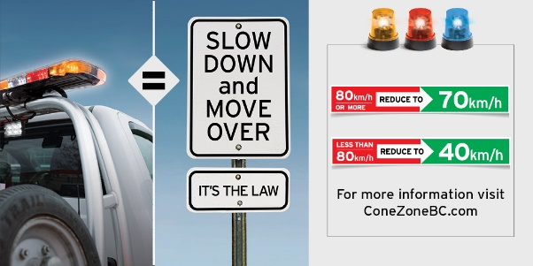
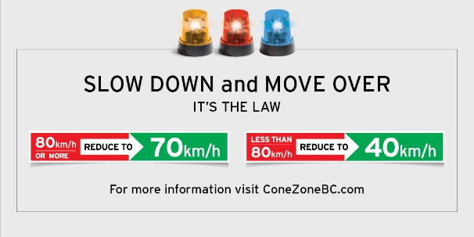

If you see flashing yellow, red or blue, what do you do? Always slow down and move over for these vehicles stopped roadside. These flashing lights mean people are also working roadside. https://www.conezonebc.com/worker-tools/slow-down-and-move-over-law-protects-roadside-workers #ConeZoneBC

Flashing lights, whether yellow, red or blue on vehicles stopped roadside… are a signal for you! People are working roadside. Slow down and move over to keep them safe. https://www.conezonebc.com/worker-tools/slow-down-and-move-over-law-protects-roadside-workers #ConeZoneBC

What do these flashing lights mean to you? They mean everything to a roadside worker. Slow down and move over for these vehicles stopped roadside. It’s the law. https://www.conezonebc.com/worker-tools/slow-down-and-move-over-law-protects-roadside-workers #ConeZoneBC
Did you know? These flashing lights on vehicles stopped roadside don't just mean tow! Roadside workers range from BCAA drivers to Telus workers. Slow down when you see them.

https://www.conezonebc.com/worker-tools/slow-down-and-move-over-law-protects-roadside-workers/#ConeZoneBC

Only 88% of drivers always slow down and move over for emergency response vehicles. What!? These workers are helping save lives. Help save theirs. Slow down, move over, and pay attention. It’s the law. https://www.conezonebc.com/worker-tools/slow-down-and-move-over-law-protects-roadside-workers/ #ConeZoneBC

Vehicles with flashing amber lights are providing important and often essential services, yet only half of drivers always slow down and move over for them. Fines are in place for drivers who don’t. Slow down, move over and keep workers safer. https://www.conezonebc.com/worker-tools/slow-down-and-move-over-law-protects-roadside-workers/ #ConeZoneBC

Roadside workers include truck drivers, first responders, tow operators, utility workers, flaggers, and garbage handlers. Protect them by slowing down and moving over when you see their flashing lights. https://www.conezonebc.com/worker-tools/slow-down-and-move-over-law-protects-roadside-workers #ConeZoneBC

Flashing lights on vehicles stopped roadside, whether red, yellow or blue represent people working. Please slow down when you see them. It’s the law. https://www.conezonebc.com/worker-tools/slow-down-and-move-over-law-protects-roadside-workers #ConeZoneBC

Did you know? If the posted speed limit is GREATER than 80 km/h, drivers must slow to 70 km/h when driving near a stopped vehicle with flashing yellow, red or blue lights. https://www.conezonebc.com/worker-tools/slow-down-and-move-over-law-protects-roadside-workers #ConeZoneBC

DYK? Failure to slow down and move over for emergency and maintenance vehicles stopped roadside with flashing red, blue or yellow lights could result in a $173 fine and three penalty points. https://www.conezonebc.com/worker-tools/slow-down-and-move-over-law-protects-roadside-workers #ConeZoneBC

Did you know? If the posted speed limit is LESS than 80 km/h, drivers must slow to 40 km/h when driving near a vehicle with flashing yellow, red or blue lights. https://www.conezonebc.com/worker-tools/slow-down-and-move-over-law-protects-roadside-workers #ConeZoneBC

Did you notice? The #ConeZoneBC website has changed! View the new and improved site here: https://www.conezonebc.com and don’t forget to share it within your networks!

The #ConeZoneBC campaign site is new and improved! Please be sure to share it and spread the word of road safety! You could make a big difference. https://www.conezonebc.com

Drivers: Please slow down and pay attention in all roadside work zones. It’s the law: https://www.conezonebc.com/worker-tools/slow-down-and-move-over-law-protects-roadside-workers #ConeZoneBC

Thank you for slowing down and paying attention in roadside work zones. Someone’s family member works here. Learn more: https://www.conezonebc.com #ConeZoneBC

Headed out for a drive? Please remember to slow down for roadside workers. Their families depend on it! https://www.conezonebc.com #ConeZoneBC

Help us spread this important safety message! #ConeZoneBC is a campaign that helps prevent deaths and injuries of roadside workers. Share this post and learn more at https://www.conezonebc.com

Thank you for slowing down and paying attention in our work zones. You’re helping to keep our mom safe. Learn more at https://www.conezonebc.com #ConeZoneBC
**USE CHILD AND MOM PHOTO CHOICES ONLY**

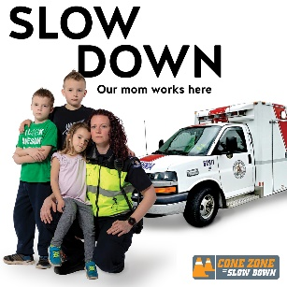

Thank you for slowing down and paying attention in roadside work zones. You’re helping to keep our dad safe. Learn more: https://www.conezonebc.com #ConeZoneBC
**USE CHILD AND DAD PHOTO CHIOCES ONLY**

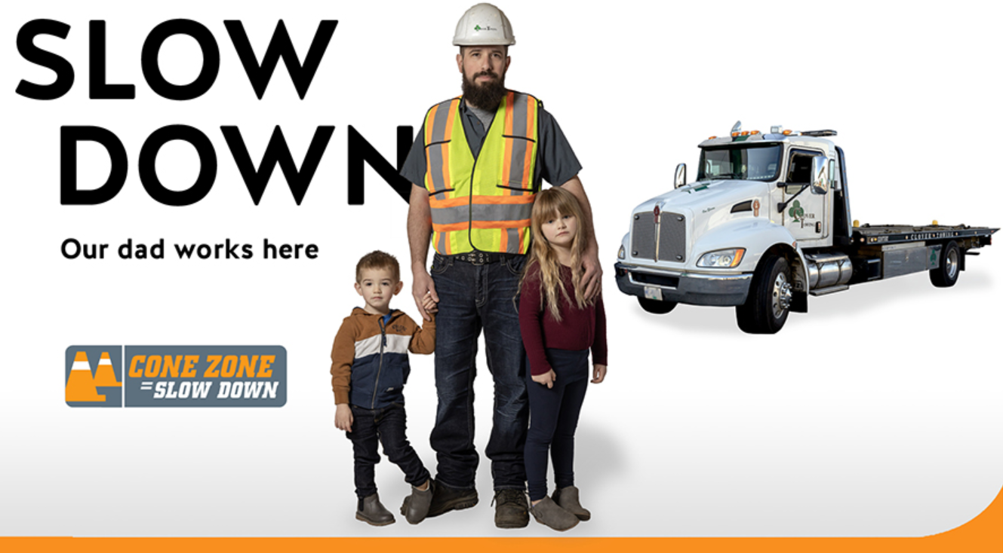

Thank you for slowing down and paying attention in roadside work zones. You’re helping to keep our loved one safe. Learn more at https://www.conezonebc.com #ConeZoneBC
**USE LOVED ONE(S) PHOTO CHOICES**

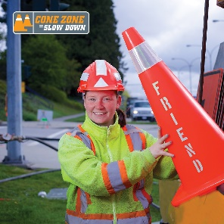

Please slow down and pay attention to all traffic control devices, signs and persons. If there are blue, red or yellow flashing lights on vehicles stopped roadside, slow down and move over to an open lane as soon as it is safe to do so. https://www.conezonebc.com #ConeZoneBC

Your text can wait. Please leave your phone alone while driving https://www.conezonebc.com #ConeZoneBC

It’s just not worth touching your phone when entering a roadside work zone. Please avoid distractions. Our roadside workers really appreciate it. https://www.conezonebc.com #ConeZoneBC

By slowing down and paying attention, you’re showing your respect for roadside workers: https://www.conezonebc.com #ConeZoneBC

A great way to show respect for roadside workers is to make eye contact and be patient. Slow down, even if you don’t see anyone. More tips here: https://www.conezonebc.com #ConeZoneBC

Be sure to obey a flag person or you could be fined $196. Follow directions - it helps keep everyone safe. https://www.conezonebc.com #ConeZoneBC

What could you do with $196? This is the minimum fine for speeding in a Cone Zone. Slow down and keep everyone safe. https://www.conezonebc.com #ConeZoneBC

What could you do with $398? This is the fine for using your electronic device while driving in a Cone Zone! Pay attention and keep everyone safe. https://www.conezonebc.com #ConeZoneBC

What could you do with $121? If you disobey a traffic control device, you’ll have to pay. Please slow down, pay attention and follow directions. https://www.conezonebc.com #ConeZoneBC

Every orange cone stands for the person working behind it. They are someone’s loved one. Slow Down. Learn more at https://www.conezonebc.com #ConeZoneBC

Speeding and distracted drivers are the biggest danger to roadside workers. Please don’t be one of them. Pay attention and slow down. https://www.conezonebc.com #ConeZoneBC

#ConeZoneBC Tip: Want to avoid road construction delays? Check out @DriveBC and take a different route. More tips here: https://www.conezonebc.com #ConeZoneBC

It’s that time of year! As summer approaches, roadside work across the province increases. Be sure to watch out for the orange cones, lower speed limits and most of all the vulnerable workers who are at the side of the road in your community. https://www.conezonebc.com #ConeZoneBC

Construction is just one of the many activities involving roadside worksites. Help keep our first responders, municipal workers, tow truck drivers, landscapers, utility workers and all roadside workers safe. www.ConeZoneBC.com #ConeZoneBC

People such as truck drivers, first responders, tow operators, utility workers, flaggers, and garbage handlers work in roadside work zones. Please slow down. https://www.conezonebc.com #ConeZoneBC

Posts to Accompany Videos:

Are you aware of the penalties for unsafe driving in Cone Zones? Learn about them here: https://www.youtube.com/watch?v=HpBa6DVNeH4&feature=emb_rel_end

Have you had a chance to check out our video gallery? Watch stories of real roadside workers and more here: http://bit.ly/317iDYQ #ConeZoneBC

Real people work in Cone Zones. Christy is a mom in your community. Take a moment to watch her story. https://www.youtube.com/watch?v=3w-zXj3Xge4 #ConeZoneBC

Real people work in Cone Zones. Mitchell is a dad in your community. https://www.youtube.com/watch?v=pr_4GcqjXtM #ConeZoneBC

Do you see the flag person when driving through roadside work zones? Thank you for slowing down and paying attention to road construction workers. https://www.youtube.com/watch?v=5FY21GJzoXQ #ConeZoneBC

A Cone Zone is somebody’s office. Please remember to slow down and pay attention when driving through one. https://www.youtube.com/watch?v=HpBa6DVNeH4&t=12s #ConeZoneBC

According to industry stats, one tow operator every six days is killed in North America. Watch this video about a real dad that works as one: https://www.youtube.com/watch?v=pr_4GcqjXtM
#ConeZoneBC

There are many types of workers in Cone Zones including emergency response personnel. https://www.youtube.com/watch?v=ofVpm76VlKg #ConeZoneBC

Tow truck operators are vulnerable as they work at the side of the road. Please slow down and pay attention in roadside work zones so they can get home safety to their family at the end of the day. https://www.youtube.com/watch?v=MfjA976KPfo #ConeZoneBC

AFADs

Automated Flagger Assistance Devices (AFAD) are only going to become more common on #BCroadways. When approaching one, be sure to wait until the red light switches to yellow and the gate rises. Help keep everyone safe. Learnmore: https://www.tranbc.ca/2022/08/26/why-automated-flagger-assistance-devices-afad-are-here-to-stay/ @TranBC #ConeZoneBC

Automated Flagger Assistance Devices (AFAD) are only going to become more common on #BCroadways. Some drivers may not be familiar with the way they work, causing confusion at some work zones. When approaching an AFAD with its gate down and red light shining, do not drive ahead. Wait until the red light switches to yellow and the gate rises. Help keep everyone safe in roadside work zones. Learn more:

https://www.tranbc.ca/2022/08/26/why-automated-flagger-assistance-devices-afad-are-here-to-stay @TranBC #ConeZoneBC

#CZPopQuiz Series: These messages come in pairs. Please schedule Questions and Answers a few hours apart to give your followers time to engage.

Tip: Make sure you schedule or post the answers at consistent times (ideally same thread) to encourage your audience to “check back at 2pm”. Remember to post answers at the time you specify and engage with your audiences’ responses as well by liking/and or commenting.

Example:
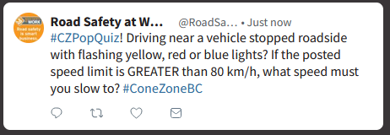

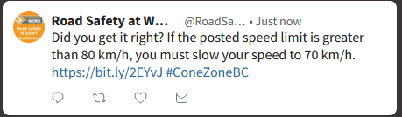

#CZPopQuiz! Driving near a vehicle stopped roadside with flashing yellow, red or blue lights? If the posted speed limit is GREATER than 80 km/h, what speed must you slow to? #ConeZoneBC

Did you get it right? If the posted speed limit is greater than 80 km/h, you must slow your speed to 70 km/h. https://www.conezonebc.com/worker-tools/slow-down-and-move-over-law-protects-roadside-workers #CZPopQuiz #ConeZoneBC

#CZPopQuiz! If you are caught distracted driving in a construction zone in British Columbia, what would the fine be? $196 or $368? #ConeZoneBC

Answer to today’s #CZPopQuiz: A whopping $368! What would you rather spend that money on? https://www.conezonebc.com #ConeZoneBC

#CZPopQuiz! Driving near a vehicle stopped alongside the road with flashing yellow, red or blue lights? If the posted speed limit is LESS than 80 km/h, what speed must you slow to? #ConeZoneBC

Did you get it right? If the posted speed limit is less than 80 km/h, you must slow your speed to 40 km/h.
https://www.conezonebc.com #CZPopQuiz #ConeZoneBC

#CZPopQuiz Driving near a vehicle stopped alongside the road with flashing yellow, red or blue lights? Is this a tow truck operator or a utility worker? #ConeZoneBC

Did we trick you? A vehicle with flashing yellow, red or blue lights could be a tow truck or a utility worker (and many other professions). Slow down and move over when you see them. #CZPopQuiz #ConeZoneBC

#CZPopQuiz! Who works in a Cone Zone? A Telus worker or a first responder? #ConeZoneBC

If you said “BOTH” in our #CZPopQuiz, you would be correct! Learn more about Cone Zones here: https://www.conezonebc.com #ConeZoneBC

#CZPopQuiz! Who works in a Cone Zone? A flag person or a utility worker? #ConeZoneBC

If your answer was “BOTH” in our #CZPopQuiz, you are correct! Find out who else works in a Cone Zone: https://www.conezonebc.com #ConeZoneBC

#CZPopQuiz! Who works in a Cone Zone? A tow truck driver, an emergency worker or a landscaper? #ConeZoneBC

Answer to today’s #CZPopQuiz: All of the above! Find out who else works in a Cone Zone: https://www.conezonebc.com #ConeZoneBC

#CZPopQuiz: What is the speed limit in a Cone Zone if there are vehicles stopped roadside with red, blue or yellow flashing lights? #ConeZoneBC

The answer to our #CZPopQuiz is a tricky one! If there are vehicles stopped with red, blue or yellow flashing lights, the Slow Down and Move Over law applies. If the posted speed is less than 80 km/h, drivers must slow to 40 km/h. https://www.conezonebc.com #ConeZoneBC

#CZPopQuiz: What is the speed limit in a Cone Zone if there are vehicles with red, blue or yellow flashing lights stopped roadside? #ConeZoneBC

The answer to our #CZPopQuiz is “it depends!” If there are vehicles with red, blue or yellow flashing lights, the Slow Down and Move Over law applies. If the posted speed is greater than 80 km/h, drivers must slow to 70 km/h. https://www.conezonebc.com #ConeZoneBC

#CZPopQuiz! If your route takes you through a Cone Zone you should: a) check DriveBC.ca to avoid delays before you leave OR b) pay attention? #ConeZoneBC

Either answer to our #CZPopQuiz, is correct! There are many things you can do when driving through a Cone Zone to keep everyone safe. https://www.conezonebc.com #ConeZoneBC

#CZPopQuiz! If you are caught speeding up to 20 km per hour over the speed limit in a construction zone in British Columbia, what would the fine be? $100 or $196? #ConeZoneBC

Answer to today’s #CZPopQuiz: A whopping $196! What would you rather spend that money on? https://www.conezonebc.com #ConeZoneBC

#CZPopQuiz: What are top two reasons for work zone crashes and fatalities? #ConeZoneBC

Answer to our #CZPopQuiz: Drivers not paying attention and excessive vehicle speed. Please slow down and pay attention when driving through a Cone Zone. https://www.conezonebc.com #ConeZoneBC

Signage Series: Please only use the appropriate signage images to accompany posts.

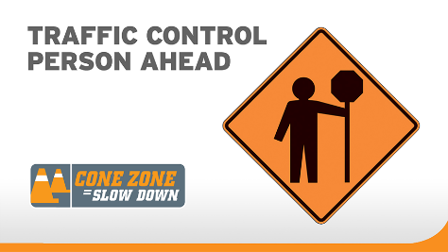
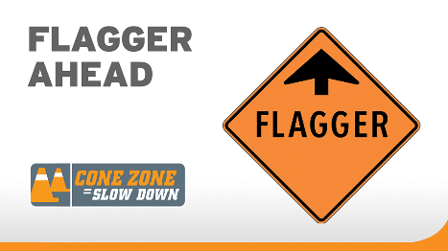

Know the signs on BC roads! These signs are telling you a traffic control person (flagger) is up ahead. Slow down and pay attention to them. https://www.conezonebc.com/drivers/know-the-work-zone-signs-in-bc #ConeZoneBC

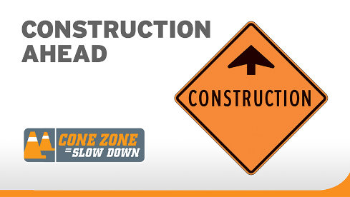

Know this sign! It’s telling drivers they are entering a construction zone. Drive with extra caution and be prepared for changes in the road and speed limit. https://www.conezonebc.com/drivers/know-the-work-zone-signs-in-bc #ConeZoneBC

